We are pleased to announce that Automatic Payment from your checking account is now available.
If you would like to sign up for Automatic Payment from your checking account, please complete the form below with a voided check and return it to our office no later than the 10th of the month. If received after the 10th of any current month your payment WILL NOT be automatically deducted until the following month. If at any time you need to stop your Automatic Payment you MUST state in writing and have turned into our office no later than the 10th of any current month.
If money is not available in your account on the due date, and the ACH is returned to us, it will be processed as a returned check and a $20 fee will be added on.
If you have any questions regarding the automatic payment service, please contact us at
859-485-4383. Please make sure your handwriting is legible along with a voided check. If voided check is not enclosed, we will not be able to process.
*************************************************************************************
NAME: ______________________________________________________________________________
SERVICE ADDRESS: ____________________________________________________________________
UTILITY ACCOUNT #: ___________________________________________________________________
DAYTIME PHONE #: ____________________________________________________________________

Please deduct my Direct Payment from my account as follows:
Name of Financial Institution: ___________________________________________________________
Financial Institution Routing Number: _____________________________________________________
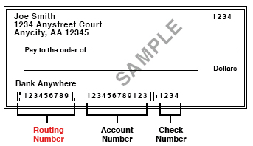

I authorize THE CITY OF WALTON to deduct my utility payment from the account listed above. I understand that if I decide to discontinue this payment, I will notify THE CITY OF WALTON in writing.
Signature: _____________________________________________ Date: _________________________

